ASSIGNMENT NO. 3: Conditional Queries and Data Filtering
Questions:
Q1) Create a database named CollegeDB and a table named Student.
The table should contain the following columns:
Column Name | Data Type | Constraint
StudentID | INT | PRIMARY KEY
StudentName | VARCHAR(50)
Age | INT
Course | VARCHAR(30)
City | VARCHAR(30)
Marks | INT
Email | VARCHAR(60)
Insert at least 10 records into the table. Some records should contain NULL values in the Email column.

Query-
CREATE DATABASE CollegeDB;
USE CollegeDB;

CREATE TABLE Student (
StudentID INT PRIMARY KEY,
StudentName VARCHAR(50),
Age INT,
Course VARCHAR(30),
City VARCHAR(30),
Marks INT,
Email VARCHAR(60)

INSERT INTO Student (StudentID, StudentName, Age, Course, City,
Marks, Email) VALUES
(1, 'Aarav Shah', 18, 'BSc IT', 'Mumbai', 85, 'aarav@email.com'),
(2, 'Meera Joshi', 19, 'BCA', 'Pune', 75, NULL),
(3, 'Rohan Patil', 20, 'BSc IT', 'Nashik', 92, 'rohan@email.com'),
(4, 'Ananya Desai', 19, 'BSc', 'Mumbai', 81, 'ananya@email.com'),
(5, 'Karan Mehta', 21, 'BCA', 'Pune', 68, NULL),
(6, 'Neha Sharma', 18, 'BSc IT', 'Mumbai', 88, 'neha@email.com'),
(7, 'Aditya Verma', 20, 'BSc', 'Nashik', 72, NULL),
(8, 'Priya Singh', 19, 'BCA', 'Pune', 95, 'priya@email.com'),
(9, 'Rahul Rao', 21, 'BSc IT', 'Mumbai', 79, 'rahul@email.com'),
(10, 'Sneha Iyer', 20, 'BSc', 'Nashik', 84, NULL);

Output-
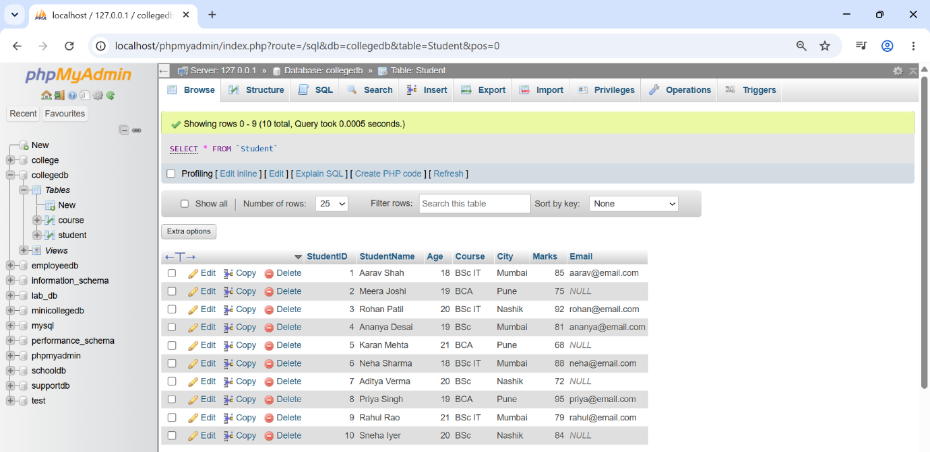

Q2) Write a MySQL query to display students who are from Mumbai and have marks
greater than 80.
The output should include:
Column
StudentID
StudentName
City
Marks

Query-
SELECT StudentID,
StudentName,
City,
Marks
FROM Student
WHERE City = 'Mumbai'
AND Marks > 80;

Output-
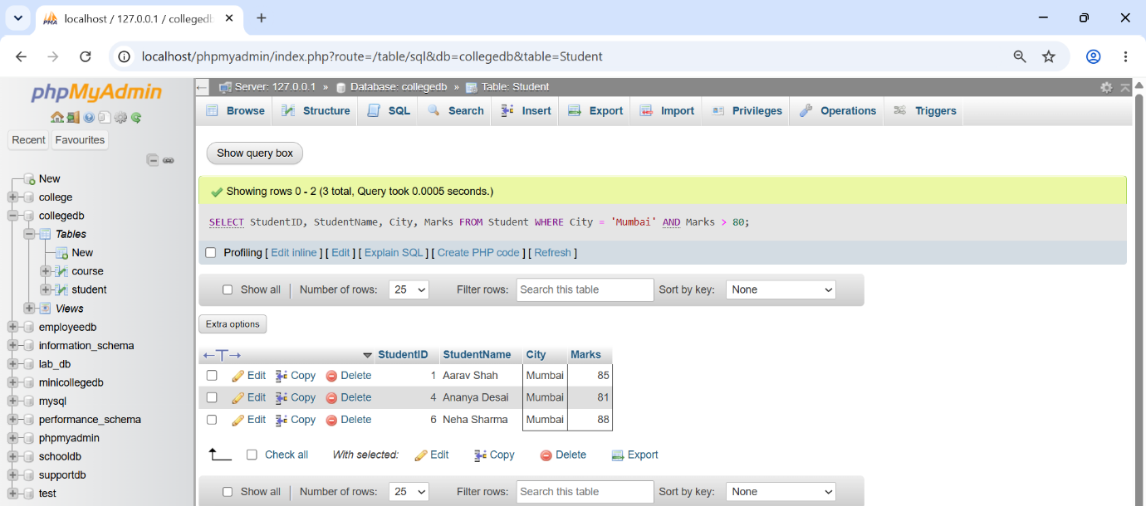

Q3) Write a MySQL query to display students who belong to either Pune or Nashik.
Use the OR operator and display the following columns:
Column
StudentName
Course
City

Query-
SELECT StudentName, Course, City
FROM Student
WHERE City = 'Pune' OR City = 'Nashik';

Output-
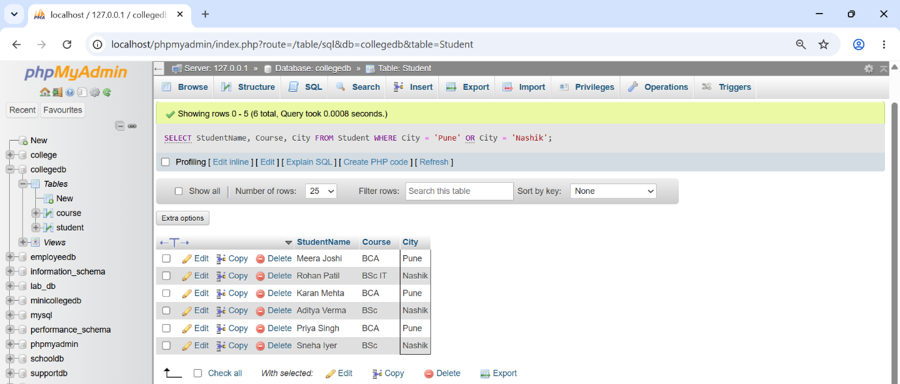

Q4) Write a MySQL query to display students whose marks are between 70 and 90.
Use the BETWEEN operator and display:
Column
StudentName
Marks

Query-
SELECT StudentName, Marks
FROM Student
WHERE Marks BETWEEN 70 AND 90;

Output-
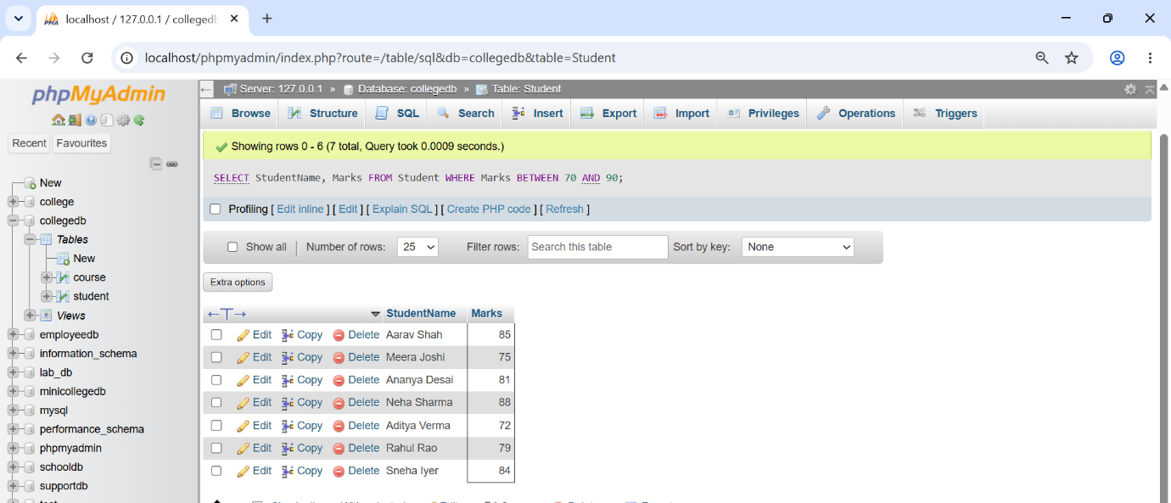

Q5) Write a MySQL query to display students whose names start with the letter A.
Use the LIKE operator and display:
Column
StudentID
StudentName

Query-
SELECT StudentID, StudentName
FROM Student
WHERE StudentName LIKE 'A%'

Output-
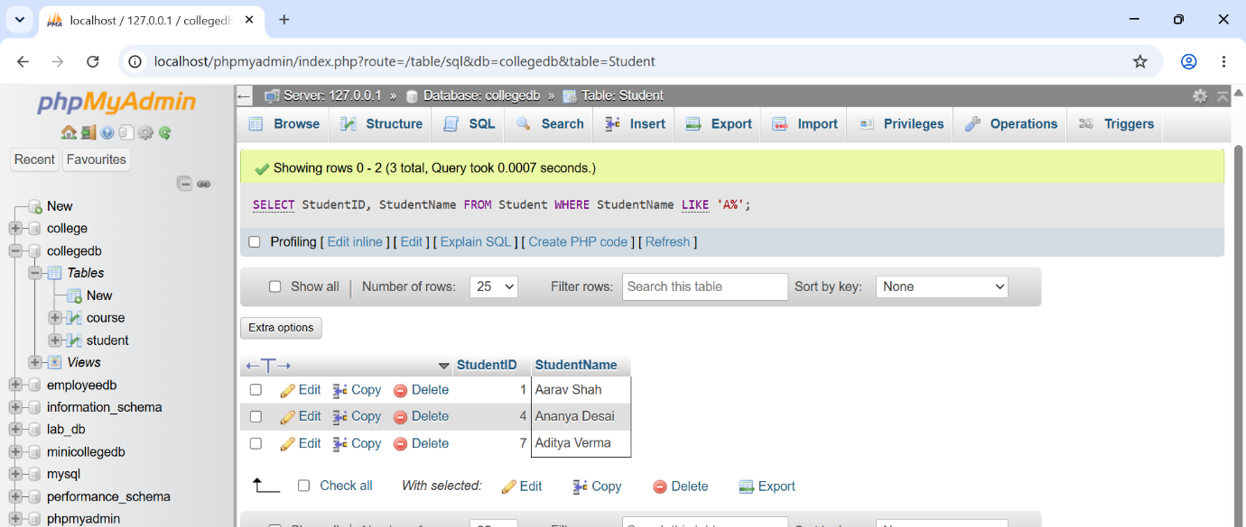

Q6) Write a MySQL query to display students whose email address is missing.
Use the IS NULL operator and display:
Column
StudentID
StudentName
Email

Query-
SELECT StudentID, StudentName, Email
FROM Student
WHERE Email IS NULL;

Output-
